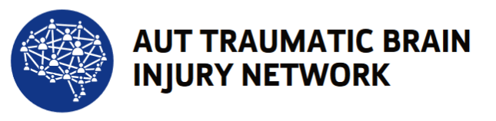

Code of Ethics for TBIN members

September 2020 - version 1.0

Membership of the AUT Traumatic Brain Injury Network (TBI-N) requires acceptance and compliance of this Code of Ethics.

The Code establishes a standard against which professional behaviour of TBI-N members may be evaluated. Behaviour contrary to the advice of the Code amounts to behaviour against the best advice of TBI-N.

The code is based upon the AUTs (TBI-N’s host organisation) values. These values should be at the heart of everything TBI-N members do

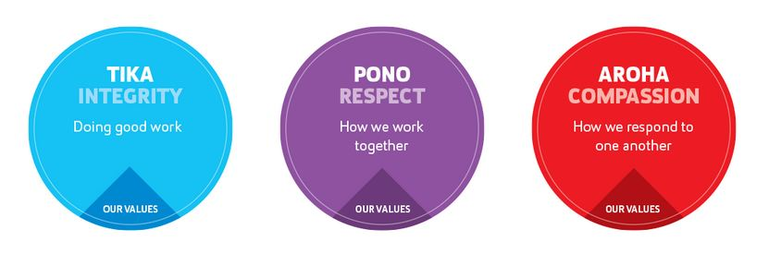

This code will be used by TBI-N in determining appropriate courses of action regarding complaints concerning the ethical behaviour of members. This Code covers all TBI-N Members while engaged in a professional capacity – whether paid or unpaid.

All members are expected to:
- conduct themselves in a way that enhances he reputation of the TBI-N and not acting in such a way to bring the TBI-N into disrepute.
- maintain a collegial and professional approach when working with other members
- maintain objectivity and integrity, and work within their scope of practice
- seek advice from other professionals/experts or the community where necessary
- respect the cultural and social environment in which they work
- hold the interests and welfare of people and their whanau who have experienced a TBI as primary importance.
- present opinions of their own, in a fair, accurate and honest manner
- only engage with media representing the TBI-N following AUT media training

Academic members/Researchers are also expected to;
- apply professional knowledge and skills to all work undertaken
- remain current with their knowledge of scientific, technical and professional information relevant to the services they offer
- ensure ethical approvals are obtained from the appropriate bodies where necessary
- ensure informed consent is obtained from research participants where necessary
- ensure research data is collected and stored in accordance with good clinical practice standards
- declare all potential conflicts of interests that could influence work within the TBI-N to the TBI-N Director to ensure these are managed correctly.
- follow protocols on the recruitment and management of research staff based on the protocols and procedures of the employing institution.
- Use the TBI-N affiliation on work publications arising from work conducted specifically within the TBI-N
- Acknowledge the TBI-N for contributions made towards research (e.g. through provision of scholarship, research costs) in research publications.

Members should develop, maintain and encourage a high standard of professional training and competence. They accept they are accountable for their own professional actions.

Members should readily provide information on professional qualifications and descriptions of services to help the public to make informed choices of the quality and type of services they can provide.

Members should be familiar with, and are expected to comply with, the requirements of their own country’s legislation

For New Zealand this includes but is not limited to the following legislation and codes:
•Privacy Act 1993This Act outlines the Privacy Principles how "agencies" collect, use, disclose, store and give access to "personal information" www.privacy.org.nz.
•Health and Safety in Employment Act 1992. The purpose of this Act is to promote the prevention of harm to all people at work, and others in, or in the vicinity of, places of work www.osh.govt.nz.
•Health Practitioners Competence Assurance Act 2003. The Acts purpose is to protect the health and safety of members of the public by providing mechanisms to ensure the lifelong competence of health practitioners www.health.govt.nz/our-work/regulation-health-and-disability-system/health-practitioners-competence-assurance-act.
•New Zealand Public Health and Disability Ethics Committees (HDECs). The primary role of the committees is to provide independent ethical review of health and disability research and innovative practice to safeguard the rights, health and wellbeing of consumers and research participants, in particular, those with diminished autonomy www.ethicscommittees.health.govt.nz.

